Merz Pies
An Ongoing Series of Site-Responsive Pies (2014—)
By Jackie Haynes

The Merz Pie recipe is principally a pie crust as a landscape shaped by a filling of locally sourced ingredients including rocks and other elements. The pie is presented with local newspapers to further connect the pie to place.

1. Stake Pie (Elterwater, Cumbria, 2014)
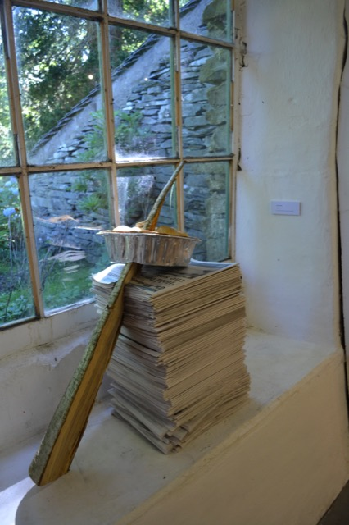
Recipe: Wooden stake, rocks, pastry
Newspaper: Westmoreland Gazette

Gala Pie (Langdale Gala ‘Best of’ Miscellaneous Category competition winner, 2014)
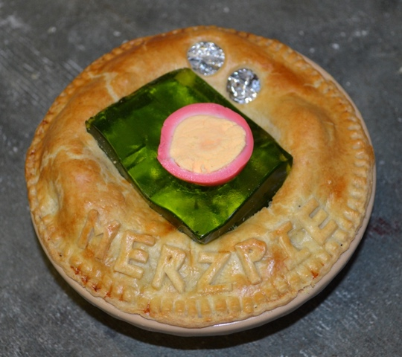
2. Stake Pie (Manchester Contemporary, 2016)

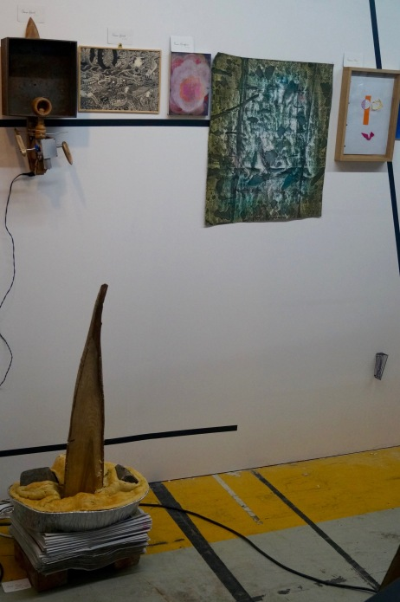

Recipe: Wooden Stake, brick, cobble stone, pastry
Newspaper: Manchester Evening News

3. Merzgebirge Pie, (Kunstkellar Annaberg, Annaberg-Buchholz Germany, 2018)

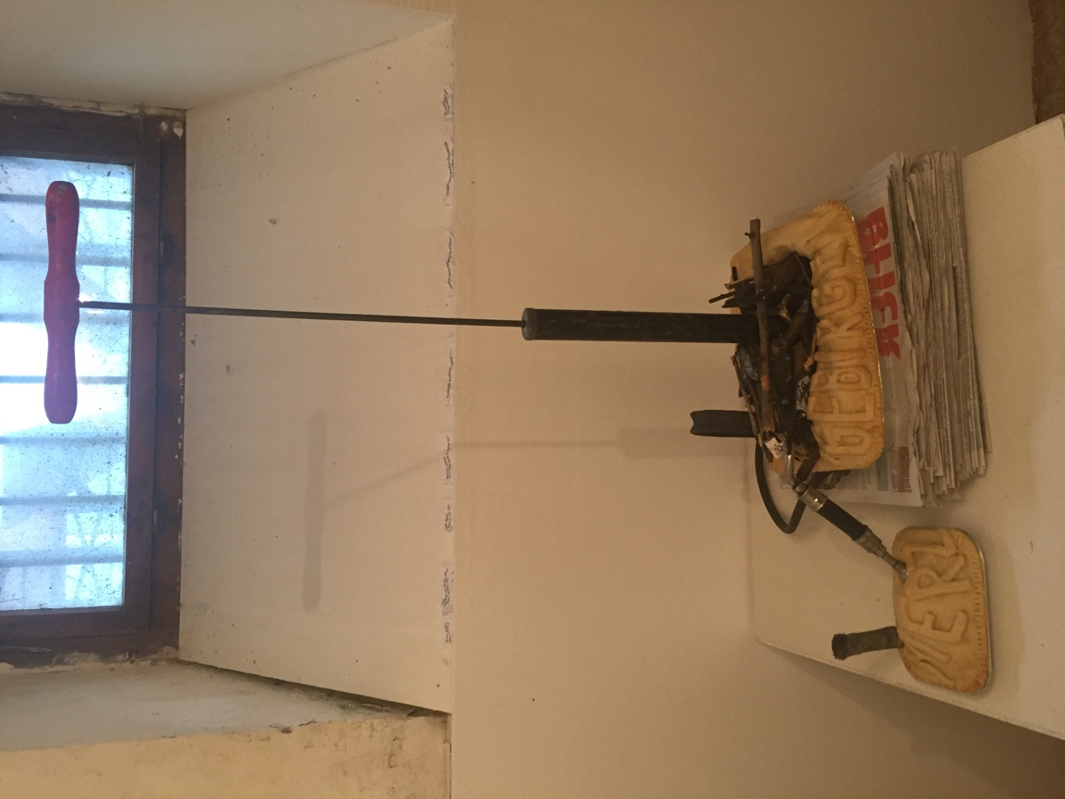

Recipe: Found objects, pastry
Newspaper: Blick

4. Carlisle Merz Pie (Geoweek, Vallum Gallery, including demo-performance, 2022)

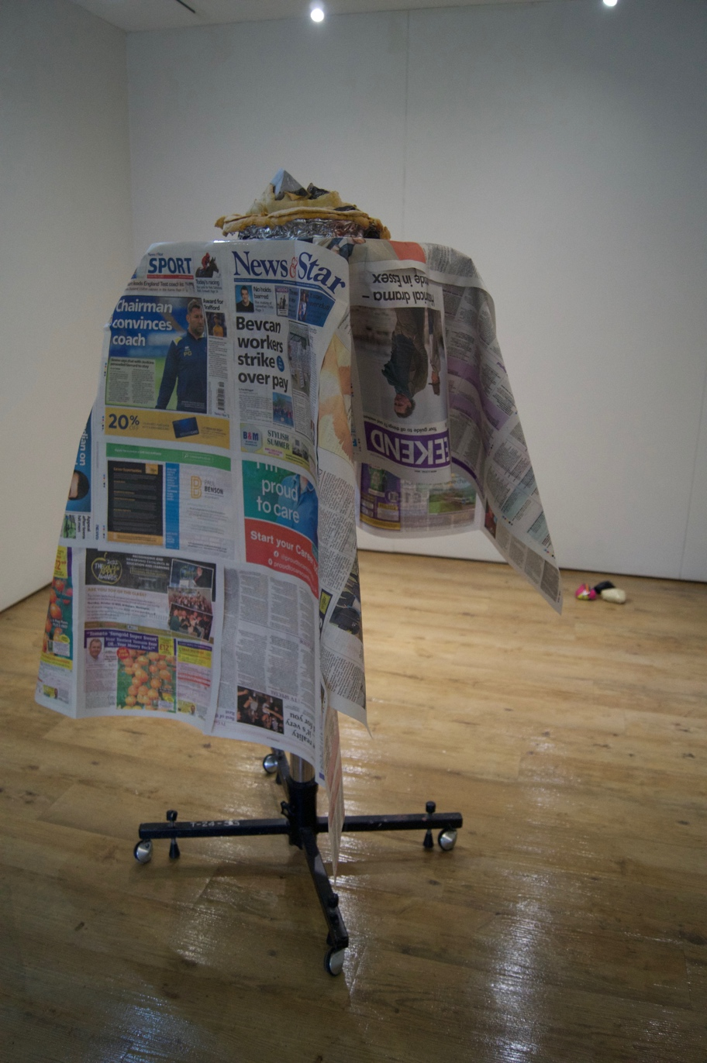

Recipe: Stone, art rock by Laura Harrison, pastry
Newspaper: News and Star, The Cumberland News

5. Keswick Merz Pie (Cumbriafest, Theatre by the Lake, performance, 2025)

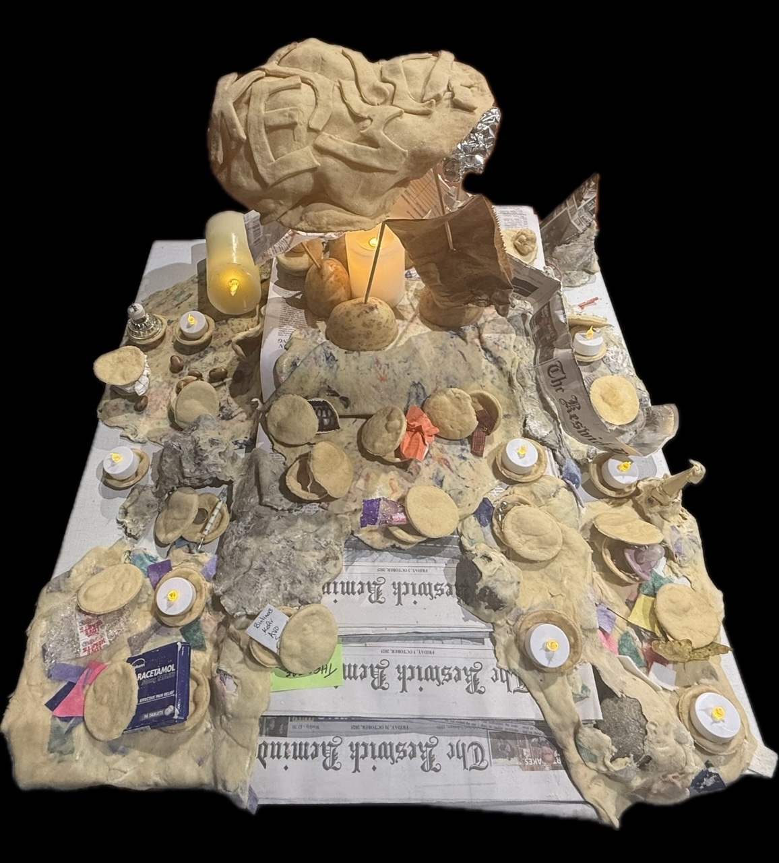

Recipe: Found objects, objects donated by audience, baked pastry, unbaked felt/tissue/newspaper pastry, rocks, broken things, LED candles, potatoes, kebab sticks
Newspaper: The Keswick Reminder

